Report Bugs/Evidence

19-05-2026

- Inventory Management

T.C 1.3.2 Empty price

the empty price still can be inputted on the add item table and still can be calculated to the total price as NaN

Evidence

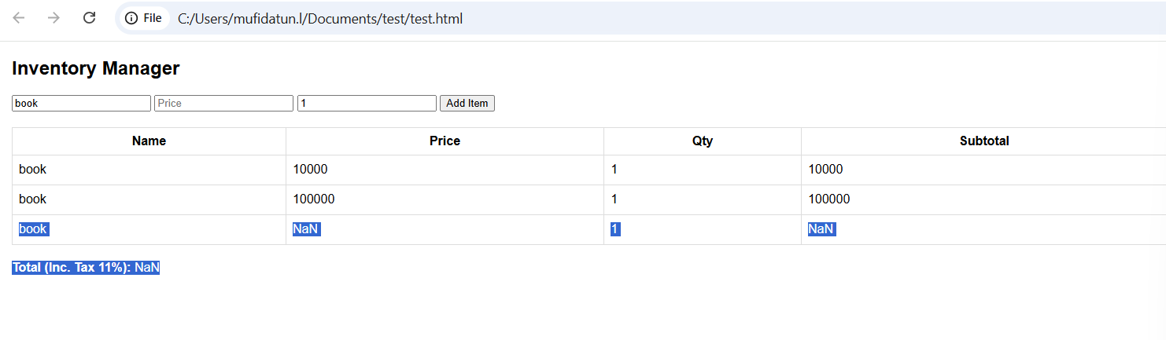

In that case, I input empty (not fill) on price input field. I expect the field can’t be empty and the data will not input to the table but the data still can be entered and the price is defined as NaN so the total price is also calculated as NaN.

T.C 1.3.3 price field - try to type non numeric data

User still can type the non numeric data (e) and still can be inputted on the add item table and still can be calculated to the total price as NaN

Evidence

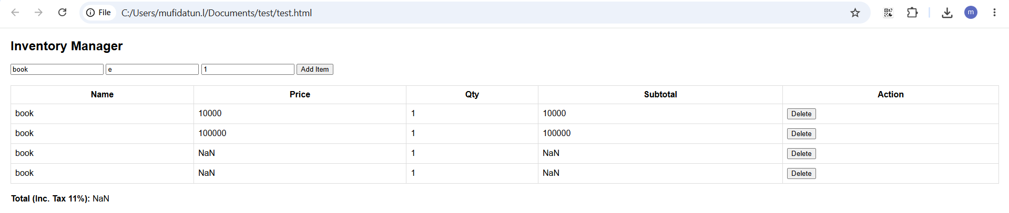

In that case, I try to input non numeric data, all the type is successfully can’t be inputted to the field except ‘e’. I expect the field can’t be inputted even with type ‘e’ and the data will not input to the table but the data still can be entered and the price is defined as NaN so the total price is also calculated as NaN.

T.C 1.3.4 input price with negative data

User still can type the negative data on the price field and still can be inputted on the add item table and still can be calculated to the total price as the negative data

Evidence

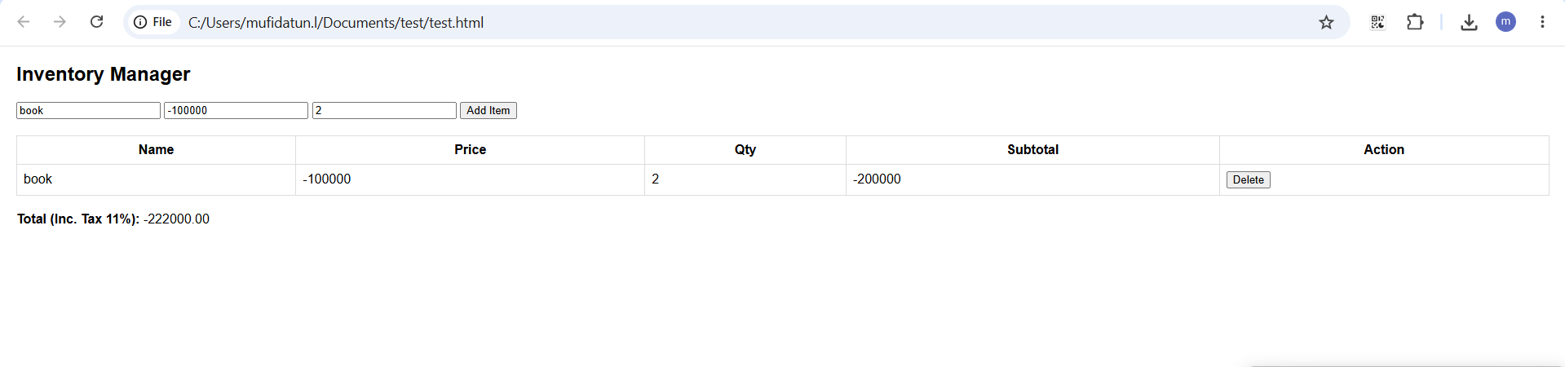

In that case, I try to input negative numeric data on the price field. I expect the field can’t be inputted with negative data it self to the price field and it should has appeared error message such as ‘can’t input less than 0’ in order that the calculation is not messed up with negative data.

T.C 1.4.2 Empty quantity input field

the empty quantity still can be inputted on the add item table and still can be calculated to the total price as NaN

Evidence

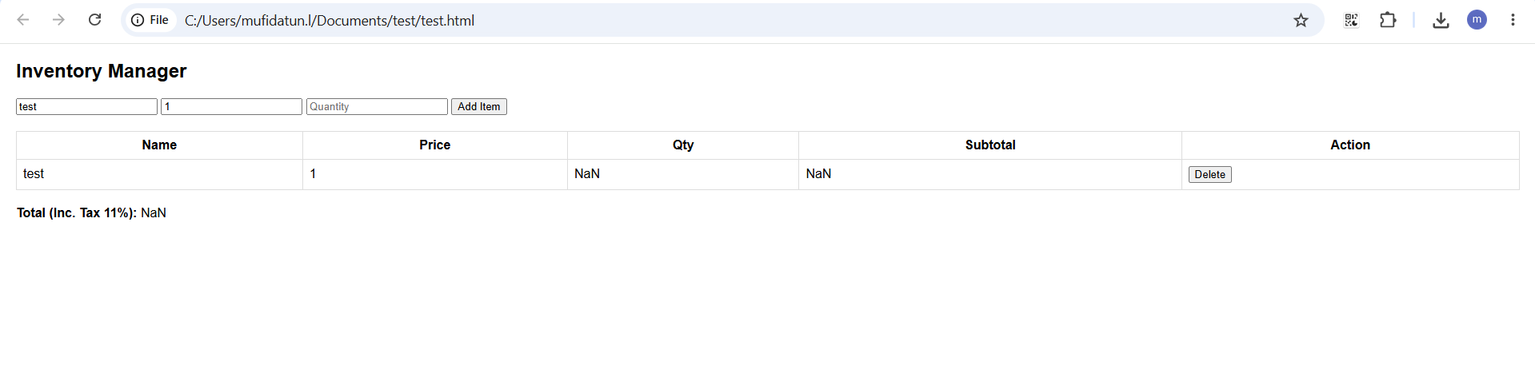

In that case, I input empty (not fill) on quantity input field. I expect the field can’t be empty and the data will not input to the table but the data still can be entered and the price is defined as NaN so the total price is also calculated as NaN.

T.C 1.4.3 quantity field - try to type non numeric data

User still can type the non numeric data (e) and still can be inputted on the add item table and still can be calculated to the total price as NaN

Evidence

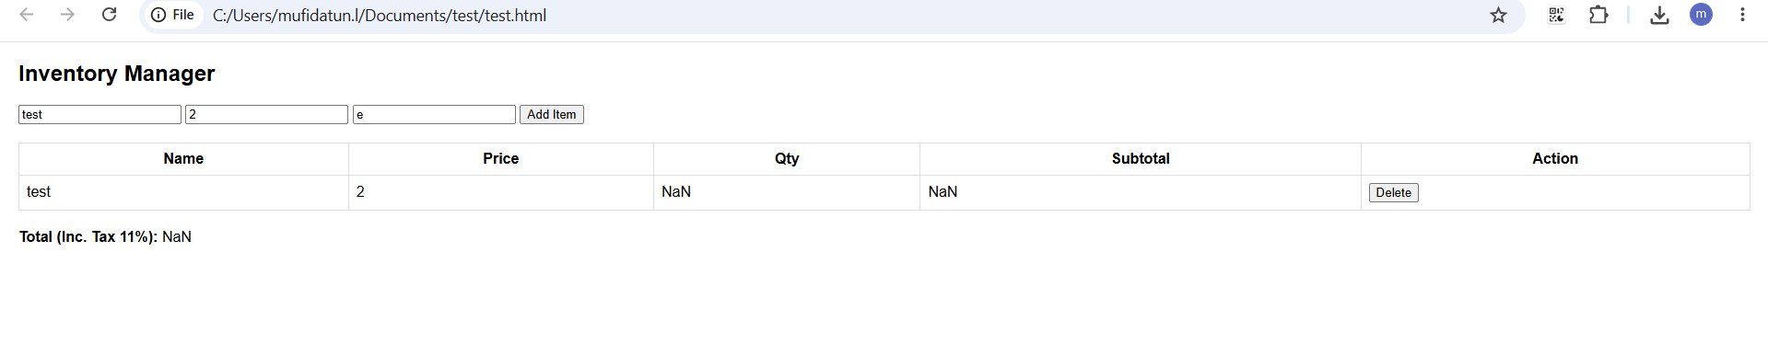

In that case, I try to input non numeric data, all the type is successfully can’t be inputted to the field except ‘e’. I expect the field can’t be inputted even with type ‘e’ and the data will not input to the table but the data still can be entered and the price is defined as NaN so the total price is also calculated as NaN.

T.C 1.3.4 input quantity with negative data

User still can type the negative data on the quantity field and still can be inputted on the add item table and still can be calculated to the total price as the negative data

Evidence

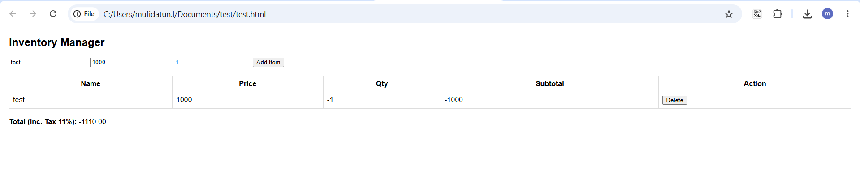

In that case, I try to input negative numeric data on the quantity field. I expect the field can’t be inputted with negative data it self to the price field and it should has appeared error message such as ‘can’t input less than 0’ in order that the calculation is not messed up with negative data.

T.C 1.1.3 delete button click button is unfunction

User can’t click the delete button on each table row and can’t delete the data if there’s a missed data to be deleted


In that case, I try to delete the messed up data on the table but when I clicked on the delete button I can’t delete the data because the button is unfunction.

